**SMART WATER MANAGEMENT**

**ABSTRACT:**

The increasing concern over water scarcity and the

need to promote sustainable water management practices

have highlighted the importance of monitoring water

consumption in public places. This abstract presents an IoT-

based water consumption monitoring system designed for

public parks and gardens. The proposed system utilizes a

network of sensors strategically placed across the area to

collect real-time data on water usage.

**OBJECTIVES:**

❖ Real-time water consumption monitoring

❖ public awareness

❖ water conservation

❖ water conservation

❖ sustainable resource management

**Real-time water consumption monitoring:**

Monitor water usage in real time to identify patterns,

anomalies, and trends in consumption, allowing for the

efficient allocation of water resources.

**Public awareness:**

Public awareness refers to the level of knowledge,

understanding, and recognition that the general public has

about a particular issue, topic, or cause. It involves

disseminating information to the public to inform, educate,

and engage them.

**WATER CONSERVATION:**

Water conservation is the practice of using water

more efficiently and responsibly to reduce waste and ensure

a sustainable water supply for the future.

sustainable resource management:

Sustainable resource management involves

responsible and efficient use of natural resources to meet

current needs without compromising the ability of future

generations to meet their own needs.

**IOT SENSOR DESIGN:**

➢ Sensor Selection

➢ Connectivity

➢ Power Source

➢ Data Processing

➢ Data Transmission

Designing IoT sensors can be complex, and it often

requires a multidisciplinary approach involving hardware,

software, and domain-specific knowledge.

**REAL TIME TRANSIT INFORMATION PLATFORM:**

➢ Data source

➢ Data integration

➢ User Interface

➢ Real-Time Updates

➢ Route Planning

➢ Accessibility

➢ Alerts and Notifications

➢ Crowdsourced Data

➢ Map Integration

Creating a real-time transit information platform often

involves collaboration with transit agencies, municipalities, and

data providers. It's essential to continuously improve the

platform based on user feedback and changing transit

conditions.

**INTEGRATION APPROACH :**

➢ Point-to-Point Integration

➢ Hub and Spoke (Enterprise Service Bus - ESB)

➢ API-Based Integration

➢ Message Queues and Publish-Subscribe

➢ Middleware Integration

➢ File-Based Integration

The choice of integration approach should be based on

your specific business requirements, existing system

architecture, scalability needs, and the level of complexity you

can manage. It's important to carefully plan, document, and

monitor integrations to ensure they remain reliable and

maintainable over time.

**ALGORITHM :**

1. *Data Collection:*

- Install sensors to measure water usage, flow rates, and

environmental factors like weather conditions.

- Use IoT devices to collect real-time data from various sources such

as homes, industries, and agricultural areas.

2. *Data Processing and Analysis:*

- Aggregate and process the collected data in real-time to identify

patterns and trends.

- Implement data analytics algorithms to analyze historical usage data

and predict future demand.

- Utilize machine learning algorithms to detect leaks, abnormal usage

patterns, and potential areas of water wastage.

3. *Decision Making:*

- Develop algorithms to make intelligent decisions based on the

analyzed data.

- Implement predictive algorithms to forecast water demand for

different areas and timescales.

- Optimize water distribution by analyzing demand patterns and

adjusting supply accordingly.

4. *User Engagement:*

- Create a user interface (could be a mobile app or a web portal) to

provide insights to consumers about their water usage.

- Implement gamification techniques to encourage water

conservation among consumers.

- Send notifications to users about their water usage, leaks, and

conservation tips.

5. *Leak Detection and Management:*

- Utilize machine learning algorithms to detect leaks in the water

supply network.

- Implement a system to automatically shut off water supply in case of

a detected leak.

- Notify maintenance teams about the location and severity of the

leak for quick repairs.

6. *Water Quality Monitoring:*

- Integrate sensors to monitor water quality parameters such as pH,

turbidity, and chemical composition.

- Implement algorithms to detect water contamination and notify

authorities for immediate action.

7. *Infrastructure Maintenance:*

- Use predictive maintenance algorithms to schedule maintenance of

pipelines, valves, and pumps before they fail.

- Implement a system to track the aging of infrastructure components

and replace them proactively.

8. *Regulatory Compliance:*

- Develop algorithms to ensure compliance with water usage

regulations and policies.

- Generate reports and alerts to notify authorities and consumers

about violations.

9. *Optimization and Feedback Loop:*

- Continuously optimize the algorithms based on feedback and

performance data.

- Implement a feedback loop where user behavior and system

performance data are used to enhance algorithms and user

engagement strategies

**PROGRAM CODE :**

# Import necessary libraries

import time

import random

# Function to simulate water level sensor data

def get_water_level():

# Simulate sensor data (replace this with actual sensor reading)

return random.uniform(0, 100)

# Function to check water level and control water usage

def smart_water_management_system():

while True:

water_level = get_water_level()

print(f"Current water level: {water_level}%")

# Implement smart water management logic based on water level

if water_level < 30:

print("Low water level! Initiating water supply.")

# Code to activate water supply mechanism goes here

# Simulate the program running every 5 seconds

time.sleep(5)

# Run the smart water management system

if __name__ == "__main__":

smart_water_management_system()

**SENSORS:**

Smart water management systems often use various sensors to monitor and control water resources. Common sensors include:

1. Flow Sensors: These measure the rate of water flow in pipes or channels, helping detect leaks, monitor water usage, and optimize distribution.

2. Water Quality Sensors: These assess parameters like pH, turbidity, dissolved oxygen, and contaminant levels to ensure water quality meets standards.

3. Level Sensors: These track the water level in reservoirs, tanks, and rivers to prevent overflows and ensure an adequate water supply.

4. Pressure Sensors: Monitoring pressure in the water distribution system can help manage water pressure and detect issues.

5. Temperature Sensors: Water temperature sensors are essential for controlling and optimizing processes, especially in industrial applications.

6. Rainfall Sensors: These detect and measure rainfall, which can inform water resource management and flood prevention.

7. Soil Moisture Sensors: Used in agriculture, these sensors monitor soil moisture levels to optimize irrigation.

8. Leak Detection Sensors: These are placed in pipelines to quickly identify and locate leaks, reducing water wastage.

9. Water Metering Sensors: Smart water meters provide accurate consumption data, enabling billing, demand forecasting, and conservation efforts.

10. Ultrasonic and Radar Sensors: These technologies can measure water levels in open bodies of water or tanks with high precision.

11. Ultraviolet (UV) Sensors: Used in water treatment, UV sensors monitor the effectiveness of UV disinfection systems.

12. Optical Sensors: These are utilized for various purposes, such as detecting impurities or monitoring water turbidity.

These sensors play a crucial role in optimizing water usage, conserving resources, and ensuring the efficient and sustainable management of water systems.

PROTOCOLS :

Smart water management systems rely on various communication protocols to collect, transmit, and process data efficiently. Some common protocols used in smart water management include:

1. *IoT Protocols*: Internet of Things (IoT) protocols like MQTT (Message Queuing Telemetry Transport) and CoAP (Constrained Application Protocol) are used to connect and communicate with sensors, controllers, and other devices in the system.

2. *SCADA Protocols*: Supervisory Control and Data Acquisition (SCADA) systems use protocols like Modbus and DNP3 (Distributed Network Protocol 3) to monitor and control remote equipment, such as pumps and valves.

3. *Wireless Communication*: Wireless protocols like Zigbee, LoRaWAN, and NB-IoT are used for long-range and low-power communication between sensors and the central control system.

4. *Bluetooth and Wi-Fi*: These are used for short-range communication, typically within homes or facilities for monitoring and controlling water-related devices.

5. *HTTP/HTTPS*: These standard web protocols are often used for data retrieval, control, and user interface access in smart water management systems.

6. **AMQP (Advanced Message Queuing Protocol)**: It's used for reliable message queuing and delivery, ensuring that data from sensors reaches the central system.

7. **MQTT-SN (MQTT for Sensor Networks)**: A variation of MQTT designed for use in sensor networks with limited resources.

8. *RESTful APIs*: Representational State Transfer (REST) APIs are used for building web services that enable communication between various components of smart water systems.

9. **OPC UA (Unified Architecture)**: It's widely used in industrial settings for interoperability and standardization of data exchange between devices.

10. *JSON and XML*: These are common data formats for encoding and transmitting configuration and measurement data between system components.

11. **DDS (Data Distribution Service)**: Often used in real-time and mission-critical applications, DDS provides a standard for data-centric communication.

The choice of protocol depends on the specific needs of the smart water management system, such as the distance over which data needs to be transmitted, the power requirements, and the types of devices and sensors being used. Interoperability and compatibility with existing infrastructure are also important considerations.

KEY ASPECTS OF COMMUNICATION:

Communication is a vital component of smart water management systems, enabling the collection, transmission, and processing of data. Here are key aspects of communication in smart water management:

1. *Sensor Data Collection*: Sensors placed in water infrastructure collect data on parameters such as flow rate, water quality, pressure, and more. This data is transmitted to a central control system.

2. *Wireless Communication*: Many smart water systems use wireless technologies like LoRa, Zigbee, or cellular networks to connect sensors, controllers, and actuators. These wireless networks are essential for remote and distributed systems.

3. *Wired Communication*: In more extensive and industrial setups, wired connections like Ethernet or fiber optic cables may be used to ensure reliable data transmission.

4. **Internet of Things (IoT)**: IoT platforms and protocols play a significant role in connecting and managing sensors and devices. MQTT, CoAP, and HTTP are commonly used for IoT communication.

5. *SCADA Systems*: For large-scale water management, Supervisory Control and Data Acquisition (SCADA) systems are employed. These systems gather and transmit data from sensors to central control centers for monitoring and control.

6. *Cloud Connectivity*: Data can be sent to cloud-based platforms for storage, analysis, and remote access. This allows water management professionals to monitor the system from anywhere with an internet connection.

7. *User Interfaces*: Smart water management systems often have web-based interfaces, mobile apps, or desktop applications for users to monitor and control the system. These interfaces communicate with the central system to provide real-time data and control capabilities.

8. *Data Analysis and Reporting*: Communication is necessary to transmit data to analytical tools and reporting systems. This enables water management professionals to gain insights, track trends, and make informed decisions.

9. *Alerts and Notifications*: Communication protocols are used to send alerts and notifications to personnel or stakeholders when anomalies or critical events occur, such as leaks or water quality issues.

10. *Interoperability*: Ensuring compatibility and communication between various components and systems within a smart water management network is crucial. Standardized protocols and interfaces facilitate interoperability.

11. *Security*: Communication in smart water management must be secure to protect against data breaches and cyber threats. Encryption, authentication, and access controls are implemented to safeguard the system.

Effective communication in smart water management is essential for optimizing water distribution, reducing waste, ensuring water quality, and responding to incidents promptly. It allows for more efficient resource management and improves the overall sustainability of water infrastructure.

**COMPONENTS:**

## 1.IoT Sensors:

Internet of Things (IoT) sensors can be deployed in water distribution systems, water treatment plants, and other relevant locations to monitor parameters such as water flow, pressure, quality, and temperature in real-time.

## 2.Data Collection and Monitoring

Data from IoT sensors and other sources are collected and monitored continuously. This data can provide insights into consumption patterns and potential issues in the water supply system.

## 3. Data Analytics:

Advanced analytics and machine learning algorithms can be used to process and analyze the data, identifying trends, anomalies, and opportunities for optimization.

**4.Remote Control and Automation:**

Smart water management systems can include automation capabilities that allow for remote control of water distribution, valve adjustments, and system operations to optimize water use in real-time.

## 5.Leak Detection:

Automated leak detection systems can pinpoint the location of leaks or abnormal water consumption patterns, helping to reduce water losses.

## 6.Consumer Engagement:

Consumers can be provided with real-time information about their water usage through mobile apps and web interfaces, encouraging responsible water consumption.

## 7.Water Quality Monitoring:

Continuous monitoring of water quality ensures that water is safe for consumption and that treatment processes are functioning properly.

## 8. Demand Forecasting:

Advanced forecasting models can predict future water demand patterns, allowing utilities to prepare for changes in consumption and optimize water distribution.

## 9.Asset Management:

Smart water management systems can assist in managing and maintaining water infrastructure assets such as pipes, pumps, and tanks, ensuring their optimal performance.

## 10.Water Conservation Measures:

Utilities can use the data and insights obtained from the system to implement water conservation measures and incentives for consumers and industries.

# WATER CONSUMPTION SENSOR TYPES:

* Mechanical Flow Meters:
  + - These meters use mechanical components like rotors or turbines to measure water flow rates.
* Ultrasonic Flow Meters:
  + - Ultrasonic sensors use sound waves to determine the velocity of water, which can then be used to calculate flow rates.
* Magnetic Flow Meters:
  + - These meters use the conductive properties of water to measure flow by inducing a magnetic field in the fluid.
* Vortex Flow Meters:
  + - Vortex shedding technology measures flow by detecting the frequency of vortices created as the fluid passes an obstruction.

# PIN DIAGRAM:

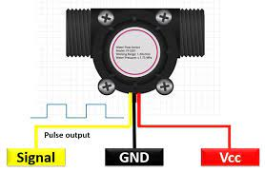

# PIN DIAGRAM CONFIGURATION:

1. **Power Supply (Vcc):**

This pin provides the power supply voltage required for the flow meter to operate. The voltage level may vary depending on the specific flow meter's requirements.

1. **Ground (GND):**

This pin connects to the ground reference, completing the electrical circuit.

1. **Signal Output (OUT):**

The flow meter may have an output pin that provides an analog or digital signal representing the flow rate. The type of signal (analog voltage, current, pulse, or digital communication protocol) can vary.

1. **Communication (COM):**

Some flow meters, especially digital ones, may have communication pins for connecting to a data logger, PLC, or control system. Common communication interfaces include RS-485, Modbus, or HART.

1. **Sensor Pins:**

Depending on the type of flow meter, there may be additional pins related to the specific sensor technology used in the meter. For example, ultrasonic flow meters may have transmitter and receiver pins.

1. **Configuration Pins:**

Some flow meters may have pins for configuring various settings, such as calibration or units of measurement. These pins might be labeled differently depending on the manufacturer.

1. **Grounding Shield (SHIELD):**

If your flow meter has a shield or grounding connection to reduce electromagnetic interference, it will have a dedicated pin for this purpose.

1. **Alarm Outputs (ALARM):**

Some flow meters may provide alarm outputs to indicate when flow rates exceed or fall below predefined thresholds.

# 2.Pressure Sensors:

Pressure sensors are used to monitor water pressure within a system, which can indirectly provide information about water consumption.

# PIN DIAGRAM:

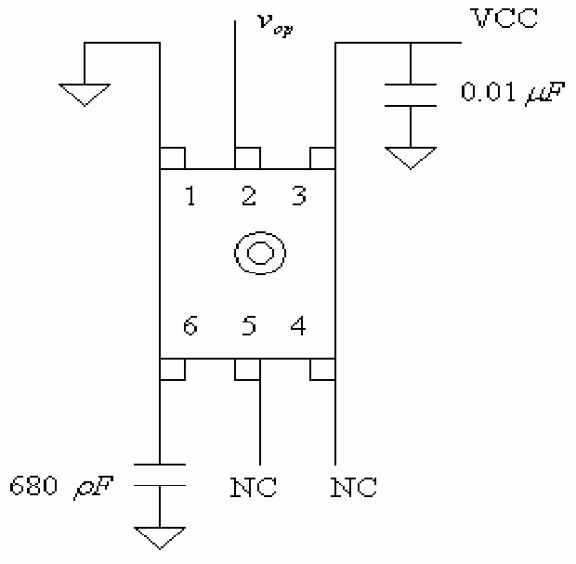

# PIN DIAGRAM CONFIGURATION:

1. **VCC (or +Vs):**

This is the supply voltage pin. You connect it to your power supply to provide the necessary voltage for the sensor to operate. The voltage level may vary depending on the sensor's specifications, but it is usually in the range of 5V to 12V.

1. **GND (or 0V):**

This is the ground or common reference point. Connect it to the ground of your power supply to establish a common ground reference.

1. **Vout (or OUT):**

This is the output pin of the sensor. It provides an analog voltage signal that varies based on the pressure detected by the sensor. You will connect this pin to an analog input on a microcontroller, data acquisition system, or another device to read the pressure value.

# 3.Smart Water Meters:

These meters are equipped with digital technology and communication capabilities, allowing for remote monitoring and data collection. They can be used in both residential and commercial settings.

# PIN DIAGRAM:

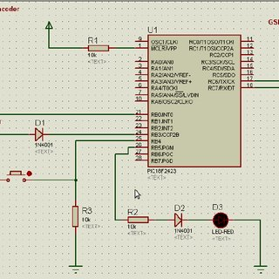

Figure 2:SMART WATER METER

# PIN DIAGRAM CONFIGURATION:

1. **Water Flow Sensor**:

The water flow sensor is a critical part of the smart water meter. It typically has a pin configuration like:

* + VCC (Power supply voltage)
  + GND (Ground)
  + Signal output (Pulse signal indicating water flow)

1. **Microcontroller or Processing Unit**:

The smart water meter usually has a microcontroller or processing unit to handle data processing and communication. The pins for this unit may include:

* + VCC (Power supply voltage)
  + GND (Ground)
  + Data input/output pins (for communication)
  + Serial communication pins (like UART, SPI, or I2C, if applicable)
  + Power-related pins (such as power enable or reset)

1. **Communication Module**:

Smart water meters often have communication modules to transmit data to a central system. Common communication methods include:

* + UART/TTL pins for serial communication with the microcontroller
  + Wired communication (e.g., Ethernet, RS-485, or RS-232 pins)
  + Wireless communication (e.g., Wi-Fi, cellular, LoRa, or Zigbee pins)

1. **Power Supply**:

The power supply pins usually consist of VCC (for supplying power) and GND (ground).

1. **Display (Optional)**:

If the smart water meter has a display, it may have pins for power, data input, and backlight control.

1. **Additional Sensors (e.g., Temperature, Pressure)**:

Some smart water meters may incorporate additional sensors for measuring temperature, pressure, or other parameters. These sensors will have their own pin configuration.

1. **Antenna (for Wireless Communication)**:

If the meter uses wireless communication, it will have an antenna or antenna connector.

1. **Battery or Power Supply Connector**:

Some smart water meters can be battery-powered. In such cases, there will be pins for connecting or replacing the batteries.

# 4.Ultrasonic Level Sensors:

Ultrasonic level sensors are used to monitor the level of water in tanks, reservoirs, and wells. They can provide data on water consumption over time by tracking changes in water levels.

DIAGRAM**:**

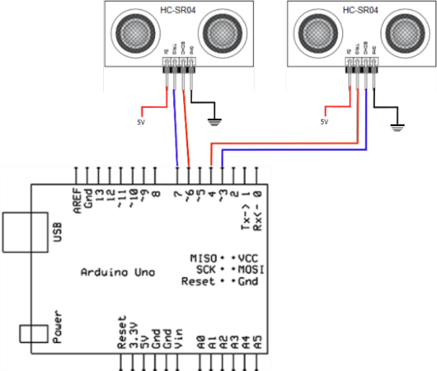

# PIN DIAGRAM CONFIGURATION:

1. **Vcc (Voltage Supply):**

This is the power supply pin. You typically provide a voltage source within the specified operating range of the sensor (e.g., 5V or 12V) to power the sensor.

1. **GND (Ground):**

This pin should be connected to the ground of your power supply, providing a common ground reference.

1. **Trigger (Trig):**

The Trigger pin is used to initiate the ultrasonic measurement. Sending a short pulse (usually a 10µs or more duration) to this pin triggers the sensor to send out an ultrasonic pulse.

1. **Echo (Echo):**

The Echo pin is used to receive the reflected ultrasonic signal. The time it takes for the signal to bounce back to the sensor is used to calculate the distance to the liquid or solid surface.

1. **Temperature Compensation (TempComp):**

Some ultrasonic sensors include a temperature compensation pin, which allows you to connect a temperature sensor for more accurate distance measurements in varying temperature conditions. This is an optional pin and may not be present on all sensors.

1. **Mode Select (Mode):**

Some sensors have a mode pin that can be used to configure the sensor for different measurement modes. This is also an optional pin, and its function can vary.

1. **Analog Output (Analog Out):**

Some ultrasonic sensors have an analog output pin that provides a continuous voltage signal proportional to the measured distance. If present, you can use this pin to obtain analog voltage readings.

1. **Serial Communication (TX, RX):**

In some advanced models, you might find TX (Transmit) and RX (Receive) pins for serial communication. These allow you to communicate with the sensor using a microcontroller or other devices for more advanced control and data retrieval.

# 5.Conductivity Sensors:

These sensors measure the electrical conductivity of water, which can be used to estimate the concentration of dissolved ions and the quality of water.

# PIN DIAGRAM:

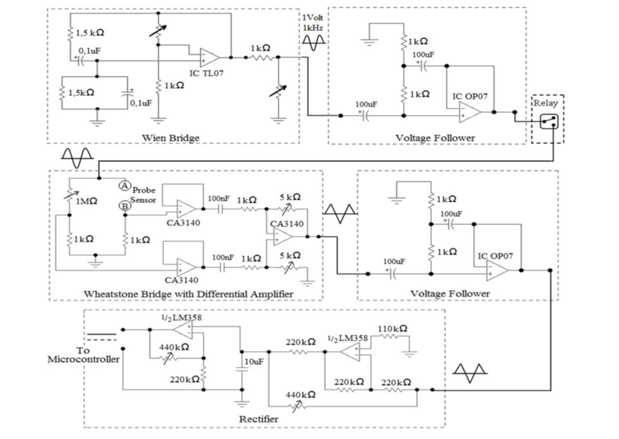

PIN DIAGRAM

# CONFIGURATION:

1. **Current Source (+):** This pin is used to provide an electrical current to the solution being tested. It is often labeled as the positive (or "+" or "I") electrode. This pin is typically connected to the red or power wire.
2. **Voltage Measurement (-):** This pin is used to measure the voltage across the solution between the two electrodes. It is often labeled as the negative (or "-" or "V") electrode. This pin is typically connected to the black or ground wire.
3. **Reference Electrode (if applicable):** Some conductivity sensors, especially those used in more complex setups, may have a reference electrode. This electrode helps stabilize the measurement and is often separate from the current and voltage electrodes.
4. **Temperature Sensor (if applicable):** In some conductivity sensors, there may be an additional pin for a built-in temperature sensor or a separate temperature compensation probe. This is used to account for temperature variations that can affect conductivity measurements.
5. **Ground (if applicable):** Depending on the design and requirements, there might be a separate ground pin to ensure a stable reference point for measurements.

# 6.Optical Sensors

Optical sensors can be used to detect the presence of water or to monitor the turbidity (cloudiness) of water, which can be an indicator of water quality.

# PIN DIAGRAM:

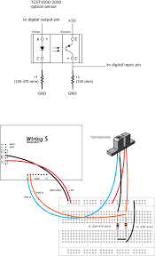

# PIN DIAGRAM CONFIGURATION:

1. VCC (Power Supply): This pin provides the voltage supply for the sensor. It typically requires a voltage within a specified range, such as 3.3V or 5V, depending on the sensor's design.
2. GND (Ground): The ground pin is connected to the common ground reference of the system.
3. Signal Output: This pin provides the output signal from the optical sensor. The type and format of the signal (analog or digital) can vary, depending on the sensor's design and intended use. You may also find additional pins for different output signals or modes (e.g., quadrature output in optical encoders).
4. LED Anode/Cathode (if applicable): Some optical sensors incorporate an LED for illumination. In such cases, there will be separate pins for the anode (+) and cathode (-) of the LED.
5. Shield/Case (if applicable): Some optical sensors may have a shield or case connected to a pin for grounding or shielding purposes to reduce electromagnetic interference.
6. Reference (REF) or Bias (if applicable): In some cases, optical sensors may include pins for reference voltage or biasing, particularly in more complex sensor designs.
7. No Connect (NC) or Unused Pins: Some sensor models may have pins that are not connected to anything or not used in a particular application. These pins are labeled as "NC."

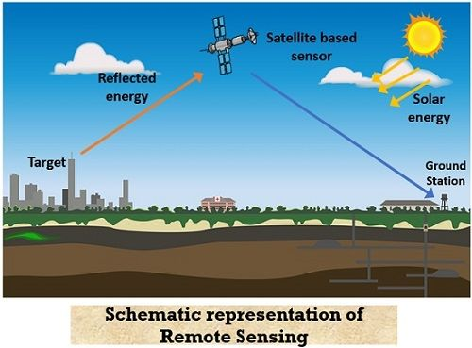

# PIN DIAGRAM CONFIGURATION:

1. **P-layer (P-type region)**: This is the first layer and is typically the top layer of the diode. It is doped with a material that has an excess of "holes" or positive charge carriers.
2. **Intrinsic layer (I-type region)**: The intrinsic region is a relatively thick, undoped layer in the middle. This layer allows for the absorption of photons and the creation of electron-hole pairs when light is incident upon the diode. It's important for the conversion of light signals into electrical signals.
3. **N-layer (N-type region)**: The N-layer is the bottom layer and is doped with a material that has an excess of electrons or negative charge carriers.

# 8.Water Quality Sensors:

While not strictly for measuring consumption, water quality sensors can monitor parameters such as pH, turbidity, temperature, and chemical composition, which can indirectly provide insights into water usage and the impact on water resources.

# PIN DIAGRAM:

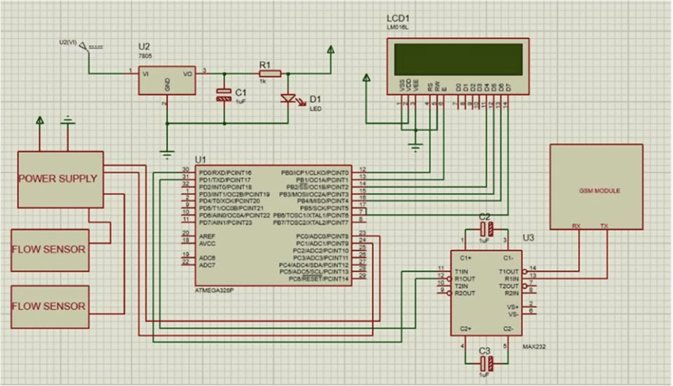

# PIN DIAGRAM CONFIGURATION:

1. **Probe**: This is the part of the sensor that comes into contact with the water to measure its properties. It typically includes electrodes for measuring various parameters like pH, conductivity, turbidity, or dissolved oxygen.
2. **Signal Output**: This is the part of the sensor that connects to your microcontroller or data logging device. It provides analog or digital signals that represent the measured water quality parameters.

The exact pin configuration can vary, but here's a general guideline:

**For a Water Quality Sensor with Analog Output**:

* VCC (Power): Connect this to a 5V or 3.3V power source on your microcontroller.
* GND (Ground): Connect this to the ground (0V) of your microcontroller.
* SIGNAL (Analog Output): This is the pin that provides the analog signal representing the measured parameter. Connect it to an analog input pin on your microcontroller.

**For a Water Quality Sensor with Digital Output**:

* VCC (Power): Connect this to a 5V or 3.3V power source on your microcontroller.
* GND (Ground): Connect this to the ground (0V) of your microcontroller.
* DATA (Digital Output): This is the pin that provides a digital signal (like a digital high or low) representing the measured parameter. Connect it to a digital input pin on your microcontroller.

# PROCEDURE:

1. **Assessment and Planning:**
   * Identify your water management goals, whether it's reducing water consumption, improving water quality, or ensuring a stable water supply.
   * Assess your current water infrastructure and practices to determine /areas that need improvement.
2. **Data Collection and Monitoring:**
   * Install sensors and meters to collect real-time data on water consumption, water quality, and system performance.
   * Implement a centralized data management system to gather and analyze data efficiently.
3. **Leak Detection and Prevention:**
   * Use water flow sensors and pressure sensors to detect leaks in the water distribution system.
   * Implement automated shutoff valves that can isolate sections of the network in case of leaks.
4. **Water Quality Monitoring:**
   * Employ sensors to continuously monitor water quality parameters such as pH, turbidity, and contaminants.
   * Set up alarms and notifications to respond promptly to water quality issues.
5. **Demand Management:**
   * Implement demand forecasting models to optimize water distribution and ensure a consistent supply.
   * Encourage water conservation and efficient water use practices among consumers.
6. **Smart Irrigation and Agriculture:**
   * Use weather data and soil moisture sensors to optimize irrigation schedules for agriculture and landscaping.
   * Utilize smart irrigation systems that adjust watering based on real-time conditions.
7. **Infrastructure Upgrades:**
   * Invest in modern infrastructure such as efficient pumps, pipes, and treatment facilities to reduce water losses and improve efficiency.
8. **Consumer Engagement:**
   * Educate and engage consumers on water conservation through apps, websites, and community programs.
   * Provide real-time consumption data to consumers to encourage responsible water use.
9. **Billing and Pricing:**
   * Implement water pricing mechanisms that reflect the actual cost of water provision and encourage conservation.
   * Use smart meters for accurate billing and to provide consumers with detailed consumption data.
10. **Emergency Response:**
    * Develop a robust emergency response plan for handling water supply disruptions, contamination events, and natural disasters.
    * Use data analytics to predict and mitigate potential issues.
11. **Regulatory Compliance:**
    * Ensure compliance with local, regional, and national water regulations.
    * Use data and reporting systems to provide necessary information to regulatory bodies.
12. **Remote Control and Automation:**
    * Enable remote control of water infrastructure, allowing for quick adjustments in response to changing conditions.
    * Automate routine tasks and maintenance activities to improve efficiency.
13. **Scalability and Integration:**
    * Ensure that your smart water management system is scalable to accommodate future growth.
    * Integrate with other smart city or utility systems for enhanced efficiency and coordination.
14. **Continuous Improvement:**
    * Regularly review and analyze data to identify areas for improvement.
    * Incorporate feedback from consumers and staff to refine the water management procedure.
15. **Training and Workforce Development:**
    * Train staff in the operation and maintenance of the smart water management system.
    * Keep your team up-to-date with emerging technologies and best practices.
16. **Public Awareness and Reporting:**
    * Communicate the benefits and progress of your smart water management efforts to the public.
    * Publish regular reports on water quality, consumption, and sustainability initiatives.

# ALGORITHM:

STEP 1: Data Collection and Sensing:

* Smart water management starts with the collection of real-time data from various sources such as sensors, weather stations, and remote monitoring systems. These sensors can measure parameters like water flow, water quality, temperature, humidity, and rainfall.

STEP 2: Data Analysis and Monitoring:

* Algorithms analyze the collected data to monitor the current state of water resources. This helps in identifying issues like leaks, over-usage, or pollution in the system.

STEP 3: Predictive Analytics:

* Smart algorithms can use historical data and machine learning techniques to make predictions about future water demand, quality, and potential issues. This can help water authorities and businesses plan for efficient water usage.

STEP 4: Demand Management:

* Algorithms can help balance supply and demand by adjusting water distribution in real-time based on demand patterns and forecasts. For example, they can optimize irrigation schedules for farmers or control water distribution in urban areas to minimize wastage.

STEP 5: Leak Detection:

* Smart water management algorithms can detect leaks in the distribution system by analyzing flow data. They can pinpoint the location of leaks and reduce water losses.

STEP 6: Water Quality Monitoring:

* Algorithms can continuously monitor water quality parameters and trigger alerts if contamination is detected. This is crucial for ensuring safe drinking water and maintaining water quality standards.

STEP 7: Infrastructure Maintenance:

* Algorithms can schedule maintenance for water infrastructure such as pipes, pumps, and treatment facilities based on predictive analytics. This proactive approach can reduce costly breakdowns and water loss.

STEP 8: Optimization of Water Treatment:

* Algorithms can optimize water treatment processes to ensure that the right treatment is applied to different water sources and conditions, saving energy and resources.

STEP 9: Water Resource Allocation:

* In agricultural contexts, smart water management algorithms can determine when and where to allocate water resources based on crop types, soil conditions, and weather forecasts to maximize yield and conserve water.

STEP 10: Remote Control and Automation:

* In some cases, algorithms can be integrated with control systems to automate valves, pumps, and other water management components, allowing for precise control and efficient operations.

STEP 11: Consumer Engagement:

* Smart water management systems can also engage consumers through mobile apps and online platforms, providing information on water consumption and tips on how to conserve water.

STEP 12: Reporting and Visualization:

* Data collected and analyzed by the algorithms can be presented to water authorities and users through user-friendly dashboards and reports, enabling data-driven decision-making.

STEP 13: Compliance and Regulation:

* These algorithms can help ensure that water management practices comply with environmental regulations and standard.

# PROGRAM:

import random

import time

class WaterLevelSensor:

def __init__(self, location):

self.location = location

def read_level(self):

# Simulate water level data (0-100%)

return random.uniform(0, 100)

class PumpController:

def __init__(self):

self.pump_status = False

def start_pump(self):

self.pump_status = True

print("Pump is turned ON.")

def stop_pump(self):

self.pump_status = False

print("Pump is turned OFF.")

def main():

sensor = WaterLevelSensor("Tank 1")

controller = PumpController()

while True:

water_level = sensor.read_level()

print(f"Water level in {sensor.location}: {water_level:.2f}%")

if water_level < 30:

controller.start_pump()

elif water_level > 70:

controller.stop_pump()

time.sleep(5) # Simulate reading the sensor every 5 seconds

if __name__ == "__main__":

main()

import random

import time

class WaterLevelSensor:

def __init__(self, location):

self.location = location

def read_level(self):

# Simulate water level data (0-100%)

return random.uniform(0, 100)

class PumpController:

def __init__(self):

self.pump_status = False

def start_pump(self):

self.pump_status = True

print("Pump is turned ON.")

def stop_pump(self):

self.pump_status = False

print("Pump is turned OFF.")

def main():

sensor = WaterLevelSensor("Tank 1")

controller = PumpController()

while True:

water_level = sensor.read_level()

print(f"Water level in {sensor.location}: {water_level:.2f}%")

if water_level < 30:

controller.start_pump()

elif water_level > 70:

controller.stop_pump()

time.sleep(5) # Simulate reading the sensor every 5 seconds

if __name__ == "__main__":

ma

• Smart water management encompasses a

range of strategies, technologies, and

practices aimed at efficiently and

sustainably managing water resources.

Key components and aspects of smart

water management include:

➢Sensors

➢Monitors

➢Data

**IOT MONITORING SYSTEM COMPONENTS**:

IoT (Internet of Things) monitoring components

play a crucial role in smart water management by collecting real-time

data and enabling efficient

water resource management. Here are someessential IoT monitoring components for smart

**water management:**

1. *Sensors:* Various types of sensors are

deployed throughout the water system, including

water quality sensors, flow sensors, pressure

sensors, and water level sensors. These sensors

collect data on water parameters and

infrastructure conditions.

2. *Smart Meters:* Smart water meters are

installed at consumer locations to monitor water

consumption. These meters provide accurate and

real-time data, allowing consumers to track their

usage and water utilities to bill accurately.

3. *Remote Terminal Units (RTUs):* RTUs are

responsible for collecting data from sensors and

meters, then transmitting this information to a

central control system or a cloud-based platform.

They play a critical role in data aggregation and

transmission.

4. *Communication Networks:* IoT monitoring

components rely on communication

networks,such as cellular, Wi-Fi, LoRa, or LPWAN

(Low-Power Wide-Area Network), to transmit

data. The choice of network depends on the

specific requirements and location of the water

management system.

5. *Gateway Devices:* Gateway devices serve as

intermediaries between IoT sensors and the

central data platform. They aggregate data from

multiple sensors and communicate it to the cloud

or control center. Gateways often have additional

processing capability.

By integrating these IoT monitoring

components into smart water management

systems, utilities and municipalities can collect,

analyze, and act upon real-time data, leading to

more efficient, sustainable, and reliable water

distribution while reducing water waste and

operational costs.

**BENEFITS OF IOT BASED SMART WATER**

**MANAGEMENT:**

Certainly, here are the benefits of IoT-based smart water management summarized into five

**key topics:**

1. *Efficiency and Conservation:*

- Reduced Water Loss: Real-time monitoring and

leak detection minimize water losses in

distribution networks.

- Water Conservation: Consumers are

empowered to use water more efficiently,

reducing wastage.

2. *Cost Savings:*

- Operational Efficiency: Smart systems optimize

resource allocation and reduce operational costs.

- Preventive Maintenance: Predictive

maintenance strategies minimize downtime and

repair expenses.

3. *Quality and Safety:*

- Water Quality Assurance: Continuous

monitoring ensures safe and clean drinking water.

- Early Contamination Detection: Rapid response

to contamination incidents protects public health.

4. *Resilience and Sustainability:*

- Climate Resilience: Quick response to changing

conditions enhances the resilience of water

systems.

- Sustainability: Reduced water waste and

energy consumption contribute to environmental

sustainability.

5. *Data-Driven Decision-Making:*

- Informed Planning: Historical data and

predictive modeling support long-term water

resource planning.

- Regulatory Compliance: Real-time data and

reporting capabilities assist in meeting water

quality and regulatory standards.

These benefits highlight how IoT-based smart

water management systems can address critical

challenges while improving water distribution,

reducing costs, and ensuring the availability of

safe and sustainable water resources.

**WEB DEVELOPMENT USING HTML:**

<DOCTYPE html>

<html>

<head>

<title> smart water data</title>

<link rel="stylesheet" href="style.css">

</head>

<body>

<h1><font color="blue"><center>SHREE

VENKATESHWARA HI-TECH ENGINEERING

COLLEGE</font></h1>

<center><img

src="file:///C:/Users/LEGEND%20USER%205470/D

ownloads/download.jfif"></center>

<h1><font color="red"><a href="">Air Quality

Data</a></center></font></h1>

<center><img

src="file:///C:/Users/LEGEND%20USER%205470/D

ownloads/logo.png"></center>

<script src="script.js"></script>

<left><p><h2>TEAM

MEMBERS</h2><h3>V.Mounika</h3></p><left>

<h3>K.Sathya</h3>

<h3>A.Sathya</h3>

<h3>S.Vigneshkumar</h3>

<h3>R.Rajesh</h3>

<h3>S.Kirubakaran</h3>

</body>

</html>

**OUTPUT:**

SHREE VENKATESHWARA HI-TECH ENGINEERING COLLEGE



**SMART WATER MANAGEMENT**

**TEAM MEMBERS:**

V.Mounika

K.Sathya

A.Sathya

R.Rajesh

S.Vigneshkumar

S.Kirubakaran

**CONCLUSION:**

In conclusion, a smart water management system is

essential solution for addressing the growing challenges of

water scarcity, environmental conservation, and efficient

resource utilization. By integrating advanced technologies such as IoT sensors, data analytics, and automation, these systems enable real-time monitoring, accurate data analysis, and proactive decision-making in water distribution, consumption, and conservation. Implementing smart water management systems not only ensures the sustainable use of this precious resource but also promotes environmental sustainability and supports the well-being of communities worldwide. As we move forward, continued research, investment, and widespread adoption of these technologies are crucial to building a more water-secure and environmentally responsible future.

Github link :

https://github.com/mouni024/MOUNIKA.git